UML DIAGRAMS:

Behavioural diagrams

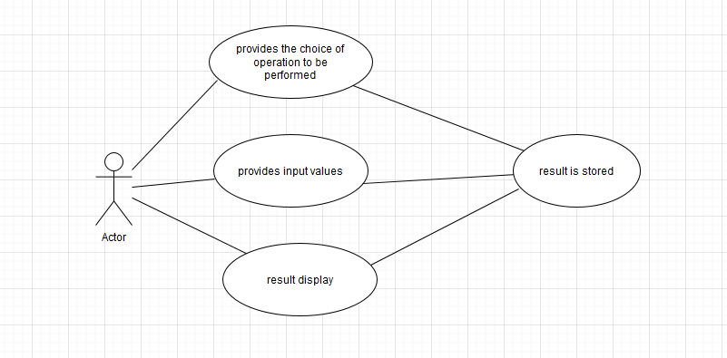

Fig 1 : Use Case diagram

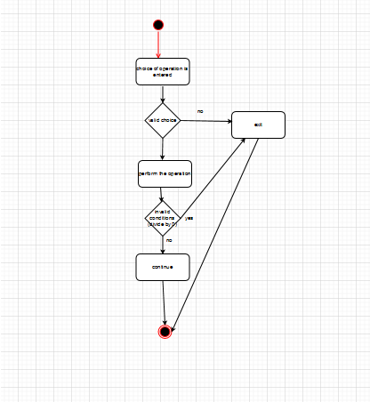

Fig 2 :Activity diagram